第十一届北京酷儿影展报名表

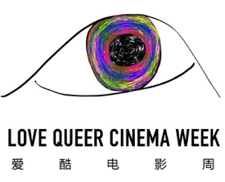
Entry form of 11th Beijing Queer Film Festival

请用中英文填写 Please fill out this form in English
片名
Original title
英文片名
English title
影片类型
Genre
片长
Length
完成时间
Accomplished Year
编剧
Screenwriter
导演
Director
主演
Cast
制片人
Producer
摄影
Cinematographer
对白语言
Dialogue Language
字幕  Subtitles | 中文Chinese ️英文English ️中英CN+EN
制作机构
Production Company
故事梗概
Synopsis

导演简历
Bio-filmography of Director

导演阐述
Director Statement

联系方式
Contact Information
样片链接和密码
Link / password to a downloadable high-quality version of your film

如果没有网络链接电子版，需要提供邮寄DVD一份，具体方式请联系报名邮箱。
If you don’t have a downloadable version of your film, please contact us to arrange for a submission with a DVD copy via postal mail.

请将报名影片剧照3张、电影海报1张、导演个人照1张，与此报名表一起发送至邮箱 info@bjqff.com
Please send this form together with a high-quality photo of director, film poster and three high-quality film stills to: info@bjqff.com

